**Lab1 CheckMyGrade Application Report**

Yuyao Ding

#018320640

1. **Identify Classes/Data Members/Member Function**

|  |  |  |  |
| --- | --- | --- | --- |
| **Sno** | **Class** | **Data Member** | **Member Functions** |
| 1 | Student | student_id  first_name  last_name  courses | display_all_students_records()  display_chosen_student_records()  display_professor_student_records()  display_student_himself_records()  check_my_grades()  check_my_marks()  add_new_student()  delete_student()  modify_student_records() |
| 2 | Course | course_id  course_name  description | display_all_courses_records()  display_chosen_course_records()  display_course_taught_by_  professor_records()  modify_course()  add_new_course()  add_new_course_professor()  delete_course() |
| 3 | Professor | professor_id  name  rank  courses | display_all_professors_records()  display_chosen_professor_  records()  display_professor_himself()  add_new_professor()  delete_professor()  modify_professor_details()  show_course_details_by_  professors() |
| 4 | Grades | student_id  course_id  grade_input  marks_input | display_all_grades_records()  display_chosen_grade_records()  display_professor_grades()  display_professor_chosen_grades()  add_new_grade()  delete_grade()  modify_grade()  grade_report_student()  grade_report_professor()  grade_report_course() |
| 5 | LoginUser | email_id  password | login()  logout()  change_password() |

1. **CSV file**

I adjusted the four CSV files in the question to become five CSV files, as follows (The table only shows partial data; for details, **please refer to the CSV files in the Main Code file**.).

Student.csv

|  |  |  |  |
| --- | --- | --- | --- |
| **Email_address** | **First_name** | **Last_name** | **Course_ids** |
| [**lindsay.blair@myscu.edu**](mailto:lindsay.blair@myscu.edu) | Lindsay | Blair | DATA217 |
| [**amanda.dudley@myscu.edu**](mailto:amanda.dudley@myscu.edu) | Amanda | Dudley | DATA202 |

Course.csv

|  |  |  |
| --- | --- | --- |
| **Course_id** | **Course_name** | **Description** |
| **DATA200** | Introduction to Artificial Intelligence | Learn the basics of AI and machine learning. |
| **DATA201** | Data Structures and Algorithms | Understand fundamental data structures and algorithms for programming. |

Professor.csv

|  |  |  |  |
| --- | --- | --- | --- |
| **Professor_id** | **Professor Name** | **Rank** | **Course_id** |
| [**jeffery.wagner@myscu.edu**](mailto:jeffery.wagner@myscu.edu) | Jeffery Wagner | Senior Professor | DATA214, DATA204, DATA215 |
| [**anthony.gonzalez@myscu.edu**](mailto:anthony.gonzalez@myscu.edu) | Anthony Gonzalez | Senior Professor | DATA212, DATA218 |

Login.csv

|  |  |  |
| --- | --- | --- |
| **User_id** | **Password** | **Role** |
| [**danielle.johnson@myscu.edu**](mailto:danielle.johnson@myscu.edu) | 3hez("@nShzA | admin |
| [**jeffery.wagner@myscu.edu**](mailto:jeffery.wagner@myscu.edu) | ~35#<+aiIey_ | professor |
| [**lindsay.blair@myscu.edu**](mailto:lindsay.blair@myscu.edu) | '"}oQK=cwVSF | student |

Grades.csv

|  |  |  |  |
| --- | --- | --- | --- |
| **Email_address** | **Course_id** | **Grades** | **Marks** |
| [**lindsay.blair@myscu.edu**](mailto:lindsay.blair@myscu.edu) | DATA217 | F | 56 |
| [**nicholas.arnold@myscu.edu**](mailto:nicholas.arnold@myscu.edu) | DATA211 | A | 97 |

Reason for the adjustment: The original Student.csv was split into Student.csv and Grades.csv.

Student.csv now contains data fields: email_address, first_name, last_name, and course_id. Grades.csv contains data fields: email_address, course_id, grades, and marks.

The primary key of Student.csv is email_address. If a student selects multiple courses and we want to retain grades and marks, email_address would need to appear twice, which conflicts with the primary key constraint of email_address. Therefore, a separate Grades.csv was created, where the primary key is a composite key consisting of (email_address, course_id).

1. **Object Oriented Design (OOD) for CheckMyGrade Application**

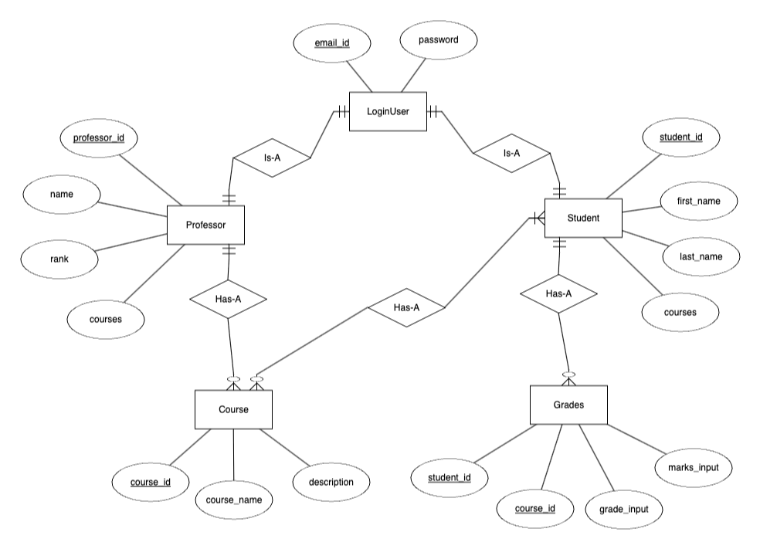

1. **Implement CheckMyGrade Application**

The specific python files and csv files can be found in the Main Code file, which includes the following:

* main.py
* common.py
* login_user.py
* encdyc.py
* data_simulate.py
* Student.csv
* Course.csv
* Professor.csv
* Grades.csv
* Login.csv
* Login_decrypted.csv (Established for the purpose of testing the code.)

All test results can be found in the **Code Terminal Output**.

1. **Test the Code**

The specific python files and csv files can be found in the Test Code file, which includes the following:

* common.py
* data_simultae.py
* encdyc.py
* test_add_student.py
* test_delete_student.py
* test_modify_student.py
* test_search_student.py
* test_search_course.py
* test_search_professor.py
* test_search_grade.py
* test_sort.py
* test_sort2.py
* test_add_course.py
* test_delete_course.py
* test_modify_course.py
* test_add_professor.py
* test_delete_professor.py
* test_modify_professor.py

All test results can be found in the **Test Code Report**.

1. **GitHub**

https://github.com/Ashley96yy/DATA200_Lab1_CheckMyGradeApplication